**AKSHAY BAJPAI**

PRE-REQUISITE

1. Snowflake : ACCOUNTADMIN

flowchart LR

**STEP 2:  Create S3 bucket & upload sample data**



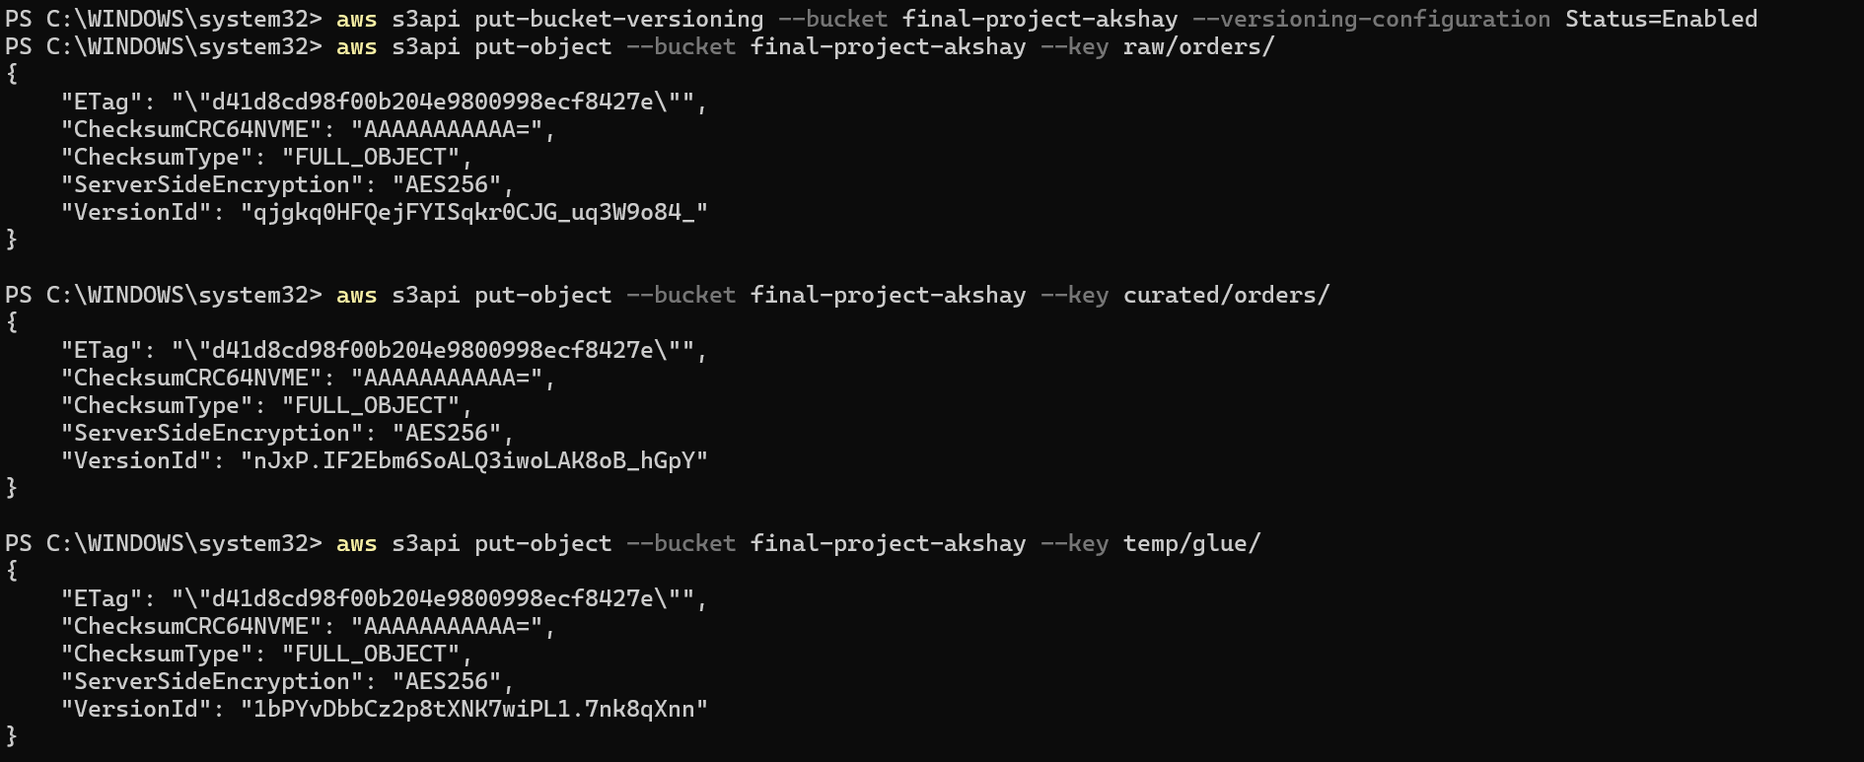

Local small dataset : orders_2024_01.csv

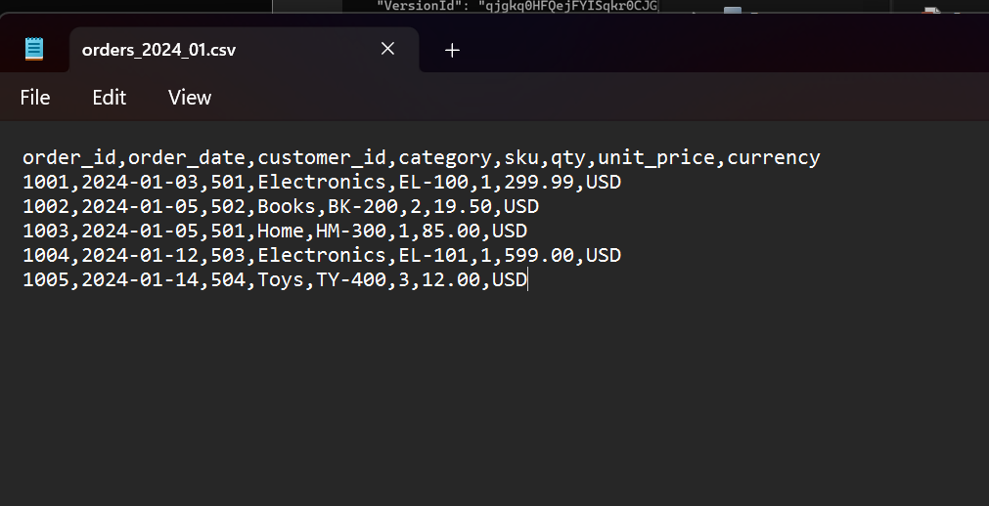

Uploading it:



**Step3: Create an IAM role for Glue**

Trust policy (Glue assumes this role)

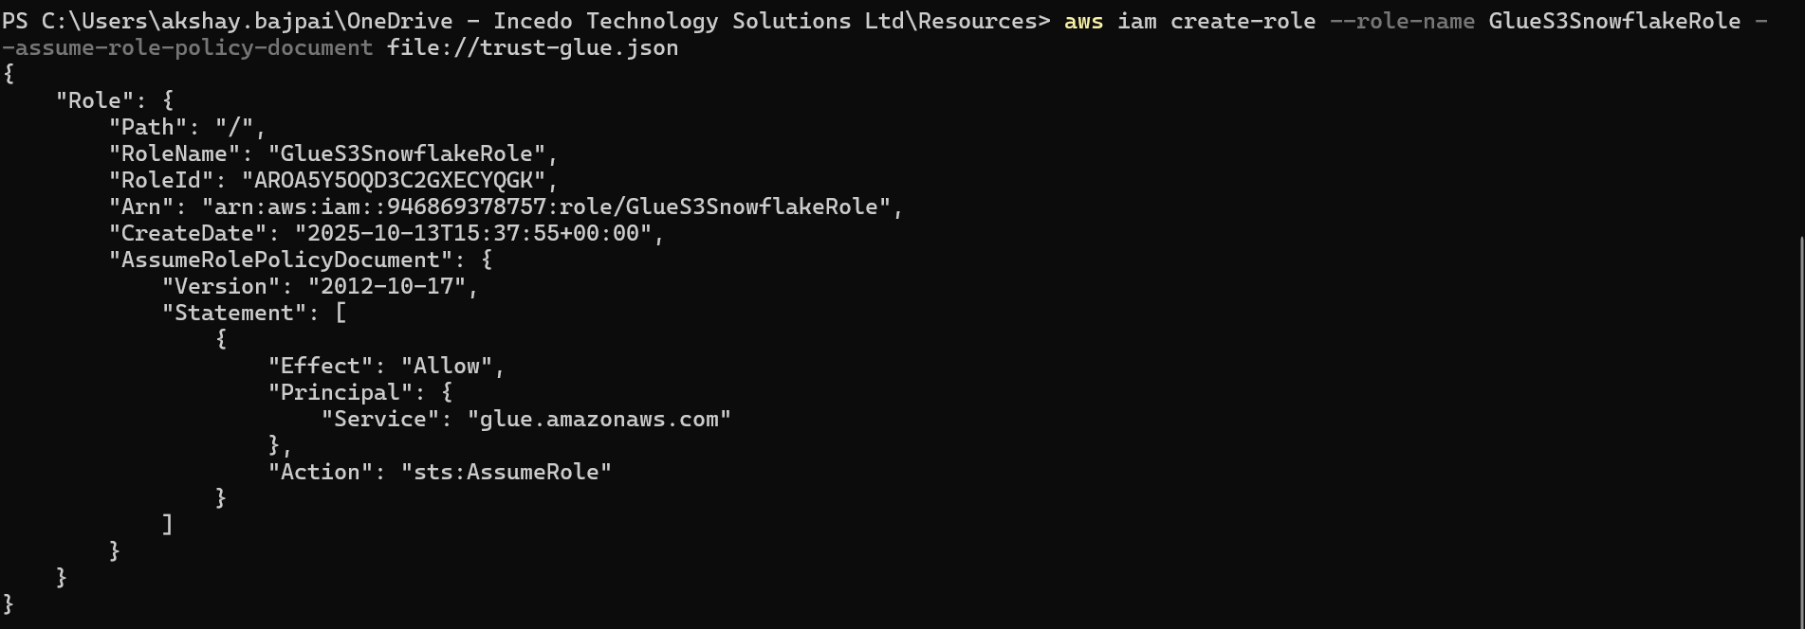

Permissions policy



STEP 4: **Catalog Raw Data with a Glue Crawler**

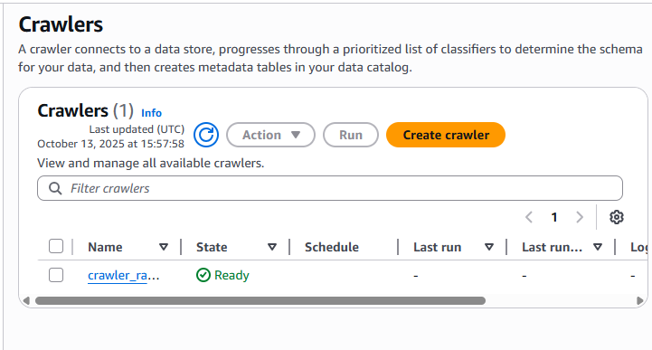

Verify Table creation

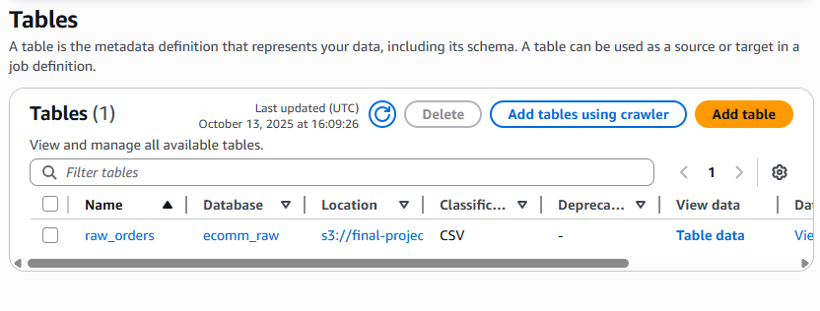

Glue job:

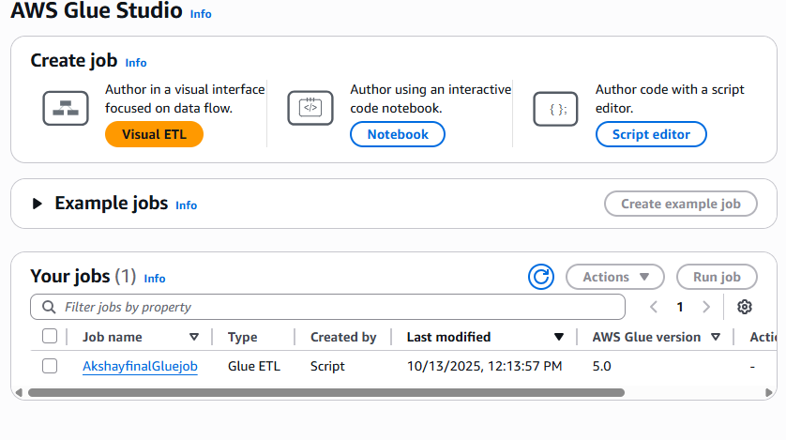

GLUE job result

**STEP 6: Snowflake: Storage Integration + Stage**

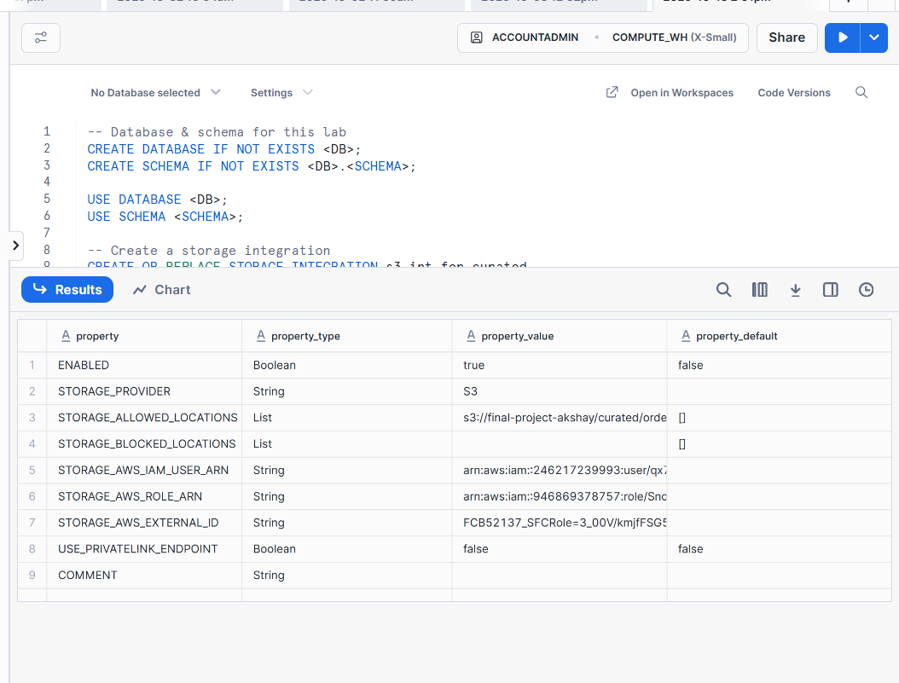

**IAM New Role for Snowflake (trust with external ID)**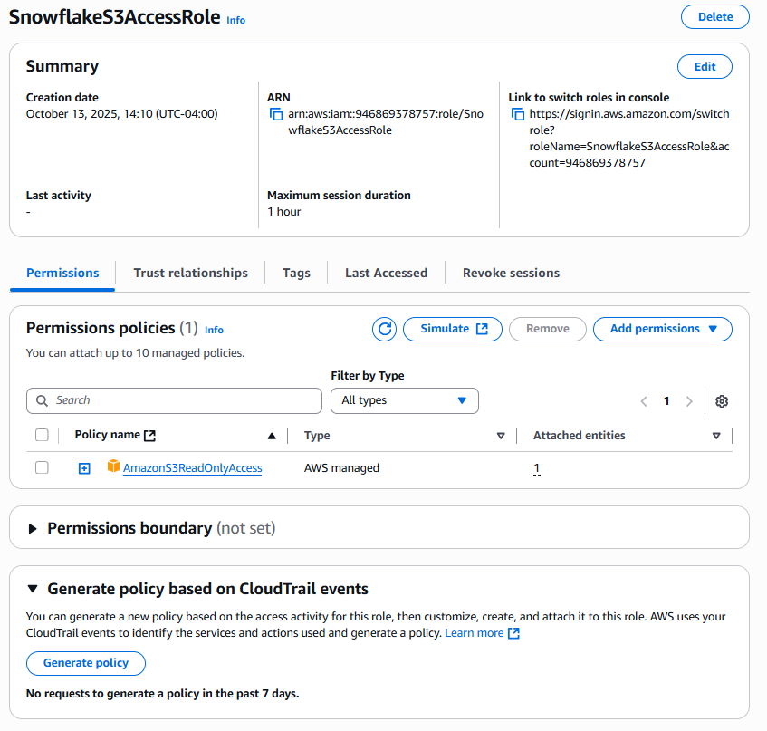

**Snowflake: Create File Format & Stage**

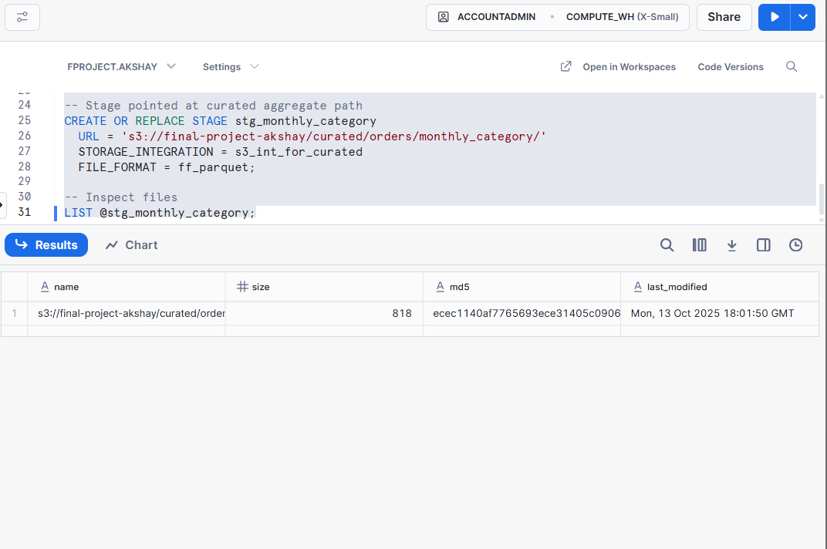

**Create target table & load data (COPY INTO)  
  
**

**Visualize in Snowsight**

**\*There is error in the query hence chart is not visible\***

